Programming Assignment 3

Bhavesh Naidu kulluru

Structure:  
  
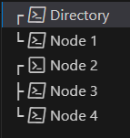

CODE:   
  
directory_server.py

import socket

import threading

import time

PORT = 5000

nodes = {}

leader_id = -1

election_in_progress = False

# Broadcast message to all nodes

def broadcast(msg):

    for node_id, node_address in nodes.items():

        try:

            with socket.socket(socket.AF_INET, socket.SOCK_STREAM) as s:

                s.connect((node_address[0], node_address[1]))

                s.sendall(msg.encode())

                print(f"Directory Server: Broadcasted to Node {node_id}: {msg}")

        except Exception as e:

            print(f"Failed to send message to {node_id}: {e}")

# Handle incoming client connections (nodes)

def handle_client(client_socket, client_address):

    global leader_id, election_in_progress

    try:

        msg = client_socket.recv(1024).decode()

        print(f"Directory Server: Received from {client_address}: {msg}")

        # Node Join

        if msg.startswith("JOIN"):

            node_id = int(msg.split()[1])

            nodes[node_id] = client_address

            print(f"Directory Server: Node {node_id} joined. Active nodes: {list(nodes.keys())}")

            broadcast(f"New Node {node_id} has joined the network.")

            if leader_id == -1 or node_id > leader_id:

                leader_id = node_id

                broadcast(f"LEADER {leader_id}")

                print(f"Directory Server: New leader elected: Node {leader_id}")

            client_socket.send("JOIN_ACK".encode())

        # Node Leave

        elif msg.startswith("LEAVE"):

            node_id = int(msg.split()[1])

            if node_id in nodes:

                del nodes[node_id]

                print(f"Directory Server: Node {node_id} left. Active nodes: {list(nodes.keys())}")

                broadcast(f"Node {node_id} has left the network.")

                if node_id == leader_id:

                    initiate_election()

        # Heartbeat from Node

        elif msg.startswith("HEARTBEAT"):

            node_id = int(msg.split()[1])

            print(f"Directory Server: Heartbeat received from Node {node_id}")

            client_socket.send("HEARTBEAT_ACK".encode())

        # Election Process Triggered

        elif msg.startswith("ELECTION"):

            node_id = int(msg.split()[1])

            print(f"Directory Server: Election message received from Node {node_id}")

            if not election_in_progress:

                election_in_progress = True

                initiate_election()

    except Exception as e:

        print(f"Error with client {client_address}: {e}")

    finally:

        client_socket.close()

# Listen for client connections (nodes)

def listen_for_clients():

    server_socket = socket.socket(socket.AF_INET, socket.SOCK_STREAM)

    server_socket.bind(("", PORT))

    server_socket.listen(5)

    print(f"Directory Server running on port {PORT}")

    while True:

        client_socket, client_address = server_socket.accept()

        print(f"Directory Server: New connection from {client_address}")

        threading.Thread(target=handle_client, args=(client_socket, client_address), daemon=True).start()

# Initiate Leader Election (Bully Algorithm)

def initiate_election():

    global leader_id, election_in_progress

    print("Directory Server: Leader election triggered...")

    if nodes:

        election_in_progress = True

        higher_nodes = [node_id for node_id in nodes.keys() if node_id > leader_id]

        if higher_nodes:

            for node in higher_nodes:

                send_election_message(node)

        else:

            leader_id = max(nodes.keys())

            broadcast(f"LEADER {leader_id}")

            print(f"Directory Server: New leader elected: Node {leader_id}")

            election_in_progress = False

# Send Election Message to Node

def send_election_message(node_id):

    try:

        with socket.socket(socket.AF_INET, socket.SOCK_STREAM) as s:

            s.connect(nodes[node_id])

            s.sendall(f"ELECTION {leader_id}".encode())

            print(f"Directory Server: Sent ELECTION to Node {node_id}")

    except Exception as e:

        print(f"Failed to send ELECTION to Node {node_id}: {e}")

if __name__ == "__main__":

    listen_for_clients()

node.py

import socket

import threading

import time

class Node:

    def __init__(self, node_id, ip_address='127.0.0.1', port=5000):

        self.node_id = node_id

        self.ip_address = ip_address

        self.port = 5000 + node_id

        self.is_leader = False

        self.server_address = (ip_address, port)

    # Join the network by connecting to the directory server

    def join_network(self):

        try:

            print(f"Node {self.node_id}: Attempting to join network at {self.server_address}")

            with socket.socket(socket.AF_INET, socket.SOCK_STREAM) as s:

                s.connect(self.server_address)

                s.sendall(f"JOIN {self.node_id}".encode())

                response = s.recv(1024).decode()

                if response == "JOIN_ACK":

                    print(f"Node {self.node_id} has successfully joined the network.")

        except Exception as e:

            print(f"Node {self.node_id}: Error joining network: {e}")

    # Leave the network

    def leave_network(self):

        try:

            with socket.socket(socket.AF_INET, socket.SOCK_STREAM) as s:

                s.connect(self.server_address)

                s.sendall(f"LEAVE {self.node_id}".encode())

                print(f"Node {self.node_id} has left the network.")

        except Exception as e:

            print(f"Node {self.node_id}: Error leaving network: {e}")

    # Send heartbeat to the directory server

    def send_heartbeat(self):

        while True:

            time.sleep(5)

            try:

                with socket.socket(socket.AF_INET, socket.SOCK_STREAM) as s:

                    s.connect(self.server_address)

                    s.sendall(f"HEARTBEAT {self.node_id}".encode())

                    response = s.recv(1024).decode()

            except Exception as e:

                print(f"Node {self.node_id}: Error sending heartbeat: {e}")

    # Receive messages from the directory server

    def receive_messages(self):

        with socket.socket(socket.AF_INET, socket.SOCK_STREAM) as s:

            s.bind((self.ip_address, self.port))

            s.listen(5)

            while True:

                client_socket, client_address = s.accept()

                message = client_socket.recv(1024).decode()

                print(f"Node {self.node_id}: Received message: {message}")

                if message.startswith("LEADER"):

                    new_leader = int(message.split()[1])

                    print(f"Node {self.node_id}: New leader elected: Node {new_leader}")

                    self.is_leader = (new_leader == self.node_id)

                elif message.startswith("New Node"):

                    print(f"Node {self.node_id}: {message}")

                elif message.startswith("ELECTION"):

                    self.handle_election(message.split()[1])

                client_socket.close()

    # Handle the election message

    def handle_election(self, sender_id):

        print(f"Node {self.node_id}: Handling election from Node {sender_id}")

        if sender_id < self.node_id:

            self.respond_to_election(sender_id)

    # Respond to an election

    def respond_to_election(self, sender_id):

        try:

            with socket.socket(socket.AF_INET, socket.SOCK_STREAM) as s:

                s.connect(self.server_address)

                s.sendall(f"OK {self.node_id}".encode())

                print(f"Node {self.node_id}: Responded with OK to Node {sender_id}")

        except Exception as e:

            print(f"Node {self.node_id}: Error responding to election: {e}")

    # Start the node processes

    def start(self):

        threading.Thread(target=self.send_heartbeat, daemon=True).start()

        threading.Thread(target=self.receive_messages, daemon=True).start()

if __name__ == "__main__":

    node_id = int(input("Enter Node ID: "))

    node = Node(node_id)

    node.join_network()

    node.start()

    leave = input(f"Do you want Node {node_id} to leave the network? (yes/no): ")

    if leave.lower() == 'yes':

        node.leave_network()

OUTPUTS:  
  
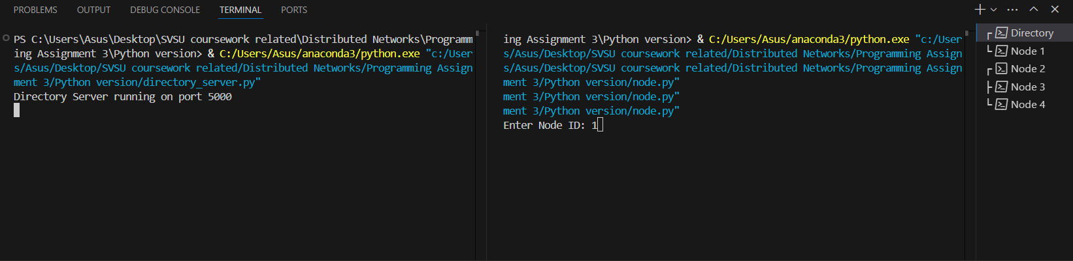

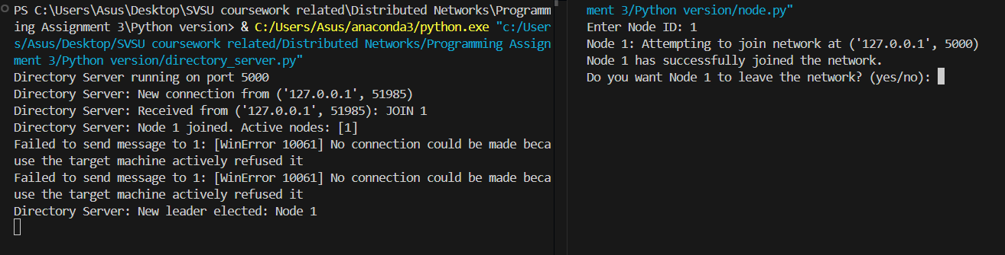

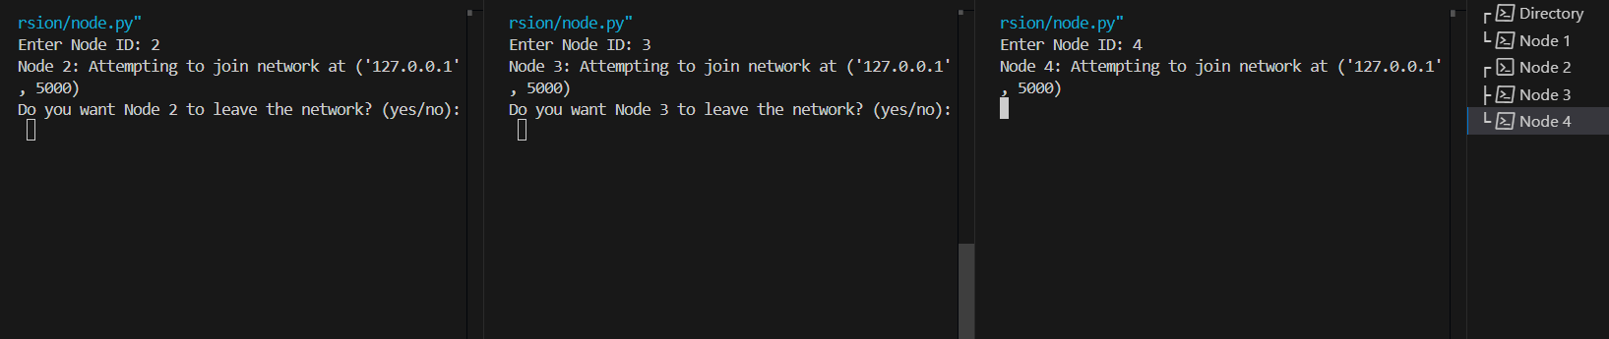

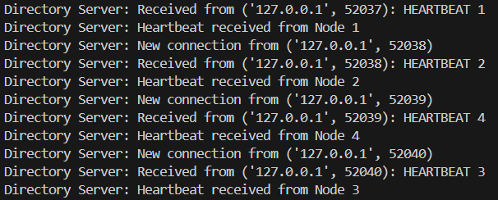

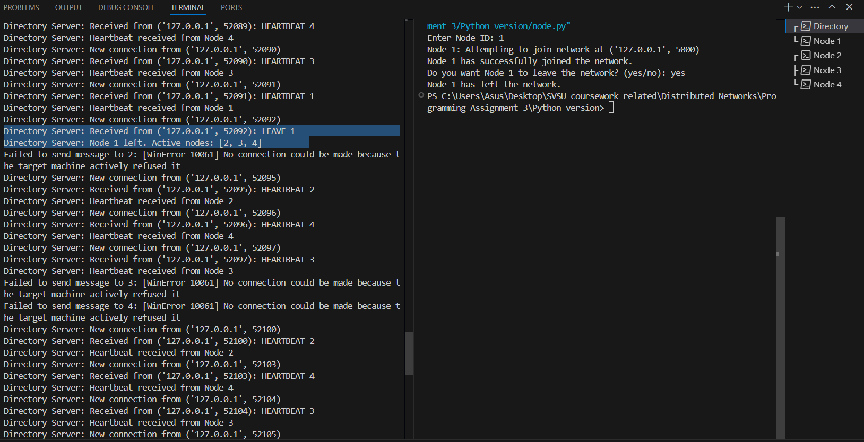

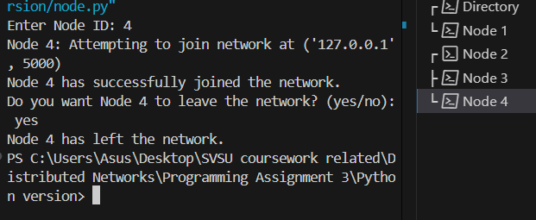

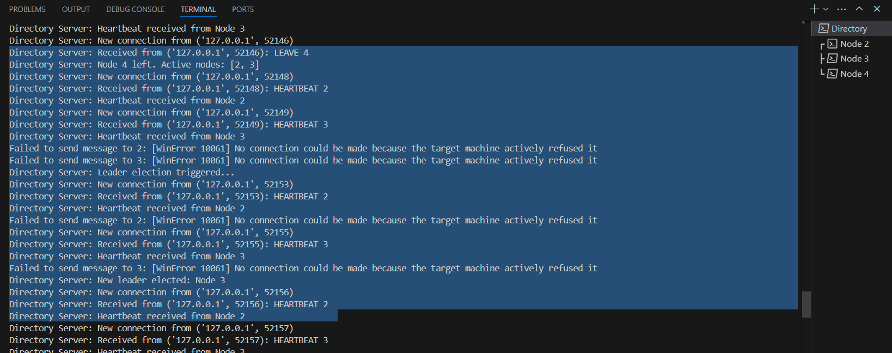

Thank YOU !!!